Software Requirements Specification

for

SkillsDekho

**Version 1.0**

**Prepared by**

**Group Name: SkillDekho**

| **Kreena Shah** | **60004210243** | **kreenashah61260@gmail.com** |
| --- | --- | --- |
| **Kapil Kashyap** | **60004210249** | **kapilkashyap3105@gmail.com** |
| **Sonia D’Silva** | **60004210251** | **sonia.dsilva.2003@gmail.com** |

| **Instructor:** | **Dr. Kiran Bhowmick** |
| --- | --- |
| **Course:** | **Software Engineering** |
| **Lab Section:** | ***C32*** |
| **Teaching Assistant:** |  |
| **Date:** | **23rd February 2024** |

**Contents**

**Revisions iii**

**1** **Introduction 1**

1.1 Document Purpose 1

1.2 Product Scope 1

1.3 Intended Audience and Document Overview 1

1.4 Definitions, Acronyms and Abbreviations 1

1.5 Document Conventions 1

1.6 References and Acknowledgments 2

**2** **Overall Description 3**

2.1 Product Perspective 3

2.2 Product Functionality 3

2.3 Users and Characteristics 3

2.4 Operating Environment 3

2.5 Design and Implementation Constraints 4

2.6 User Documentation 4

2.7 Assumptions and Dependencies 4

**3** **Specific Requirements 5**

3.1 External Interface Requirements 5

3.2 Functional Requirements 6

3.3 Behaviour Requirements 6

**4** **Other Non-functional Requirements 7**

4.1 Performance Requirements 7

4.2 Safety and Security Requirements 7

4.3 Software Quality Attributes 7

**5** **Other Requirements 8**

**Appendix A – Data Dictionary 9**

**Appendix B - Group Log 10**

**Revisions**

| **Version** | **Primary Author(s)** | **Description of Version** | **Date Completed** |
| --- | --- | --- | --- |
| Draft Type and Number | Sonia D’Silva | Requirements gathering for SkillsDekho | 16/02/24 |

# 

# Introduction

SkillsDekho, a platform that provides a platform for hosting coding contests and recruitment events.

## Document Purpose

The purpose of this document is to specify the software requirements for SkillsDekho, including its features, functionalities, and constraints. It would give the user a brief about what the user can expect from our product and what is our USP or Unique Selling Proposition of us over our competitors.

## Product Scope

SkillsDekho aims to provide a centralized platform for users to practice coding problems, enhance their theoretical knowledge, and participate in coding contests and recruitment events hosted by companies and educational institutions. The platform will offer an extensive collection of coding challenges, ranging from beginner to advanced levels, covering various programming languages and problem domains. Additionally, it will provide a learning management system (LMS) with structured courses, tutorials, and theoretical content to complement the practical coding exercises

## Intended Audience and Document Overview

This SRS document is intended for a diverse audience involved in the development, deployment, and utilization of SkillsDekho. It caters to a diverse audience, including the Development Team, Project Managers, Stakeholders, Quality Assurance and Testing Team, and Technical Writers. It provides comprehensive details on functional and non-functional requirements, design constraints, and user interfaces. The document ensures alignment with the product's vision and objectives, facilitating effective communication throughout the development lifecycle. Ultimately, adherence to the SRS ensures the delivery of a seamless user experience for coding practice, skill enhancement, and recruitment opportunities.

## Definitions, Acronyms and Abbreviations

| Abbreviation | Meaning |
| --- | --- |
| CC | Coding Contest |
| RL | Rank list |

## Document Conventions

This document uses Arial font size 11, or 12 throughout the document for text. Also it uses italics for comments. Document text is single spaced and maintains the 1” margins.

## References and Acknowledgments

Unstop: <https://unstop.com/>  
Leetcode: <https://leetcode.com/>

# Overall Description

## Product Perspective

SkillsDekho is an online platform that provides a platform for users to practice coding problems, participate in hackathons, and engage in recruitment drives, competitions, and events hosted by companies and universities. The system allows users to enhance their coding skills, showcase their talent, and connect with potential employers or collaborators.

Product Perspective Diagram

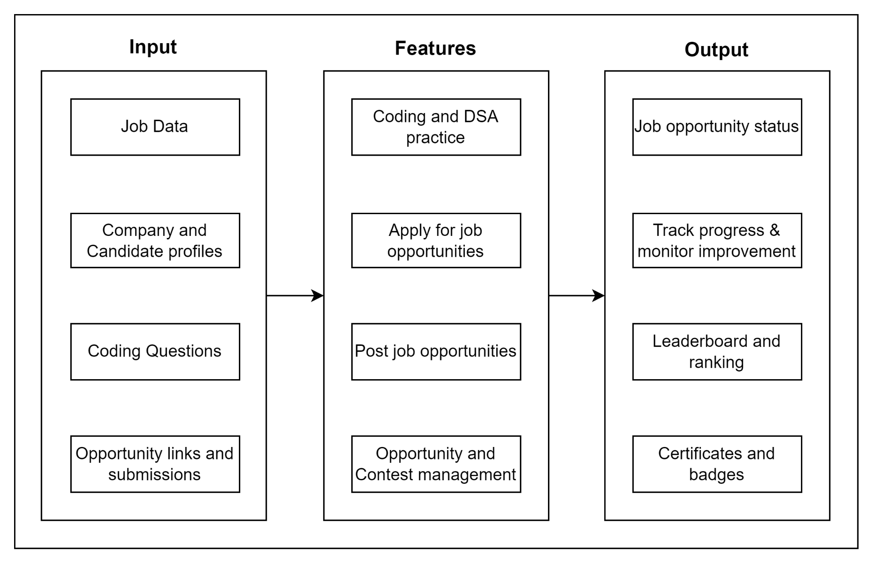

## Product Functionality

* User Registration and Authentication: Allow users to create accounts and authenticate securely.
* Coding Practice and Submission: Allow users to practice coding problems and submit their solutions for evaluation.
* Hackathon and Competition Registration: Enable users to register for hackathons, competitions, and recruitment drives hosted by companies and universities.
* Real-time Coding Environment: Provide a real-time coding environment where users can write and test their code.
* Leaderboard and Performance Tracking: Display leaderboards to track user performance in solving coding problems and participating in competitions.
* Company and University Profiles: Allow companies and universities to create profiles and host events on the platform.
* Recruitment Drive and Event Management: Enable companies and universities to manage recruitment drives, hackathons, and other events through the platform.
* User Profile Management: Allow users to manage their profiles, including updating personal information and preferences.
* Messaging and Collaboration Features: Provide messaging and collaboration features for users to communicate with each other and with event organizers.

## Users and Characteristics

* Developers, Students, Working Professionals: These users are primarily interested in practicing coding problems and participating in hackathons and competitions to improve their skills and showcase their talent.
* Companies: Companies use the platform to host recruitment drives, competitions, and events to identify and recruit talent. They are interested in accessing profiles of potential candidates.
* Universities: Universities use the platform to host competitions and events for their students and alumni. They are interested in engaging with students and promoting their programs.

## Operating Environment

SkillsDekho operates in a web-based environment, compatible with web browsers such as Google Chrome v123.0.6312.46, Mozilla Firefox v 2.9.0, and Safari v3.2.1. The platform requires a stable internet connection and supports multiple operating systems including Windows, macOS, and Linux.

## Design and Implementation Constraints

* Scalability: The platform must be designed to handle a large number of users concurrently during peak times, such as hackathons or recruitment drives.
* Security: The system must implement strong security measures to protect user data, including encryption, secure authentication, and data validation.
* User Experience: The platform must provide an intuitive user interface and seamless user experience to encourage engagement and retention.
* Competition Regulations: The platform must enforce rules and regulations for competitions and events, ensuring fair play and compliance with guidelines.

## User Documentation

SkillsDekho will provide user documentation in the form of online help and tutorials. The documentation will include guides on how to use the platform, participate in competitions, and practice coding problems. It will also provide troubleshooting tips and best practices for maximizing the benefits of the platform.

## Assumptions and Dependencies

Internet Connectivity: Users are assumed to have a stable internet connection to access the platform.

User Engagement: The success of the platform depends on user engagement and participation in competitions and events.

Server Infrastructure: The platform depends on a reliable server infrastructure to ensure uptime and performance.

# Specific Requirements

## External Interface Requirements

### User Interfaces

Our platform provides the user with an online portal, where the user must first login or signup with our website and then can access the salient features of our website.

To participate in a hackathon the user must login in or provide us with a proper college/student email Id, also the user must have a proper resume which he should upload on our portal. There is also a space for the user to upload his/her marksheets and the same data can then be used to send out to companies which will use it to hire the particular candidate.

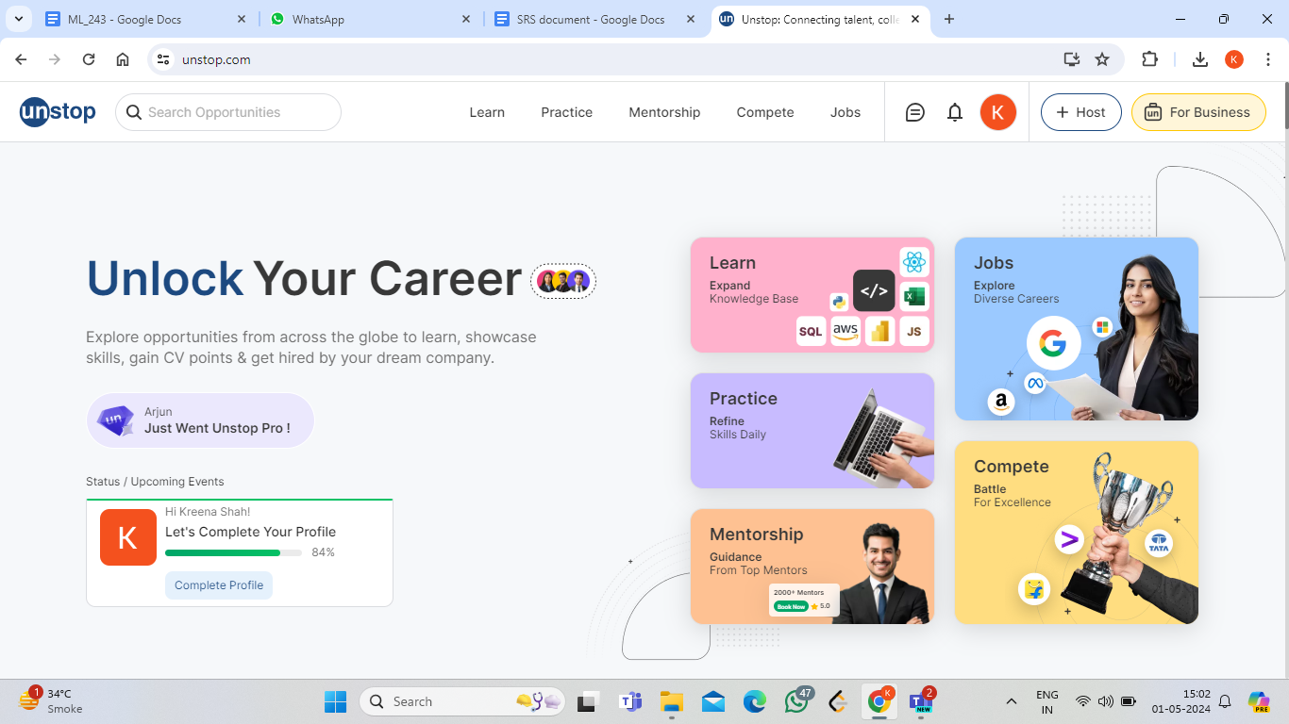

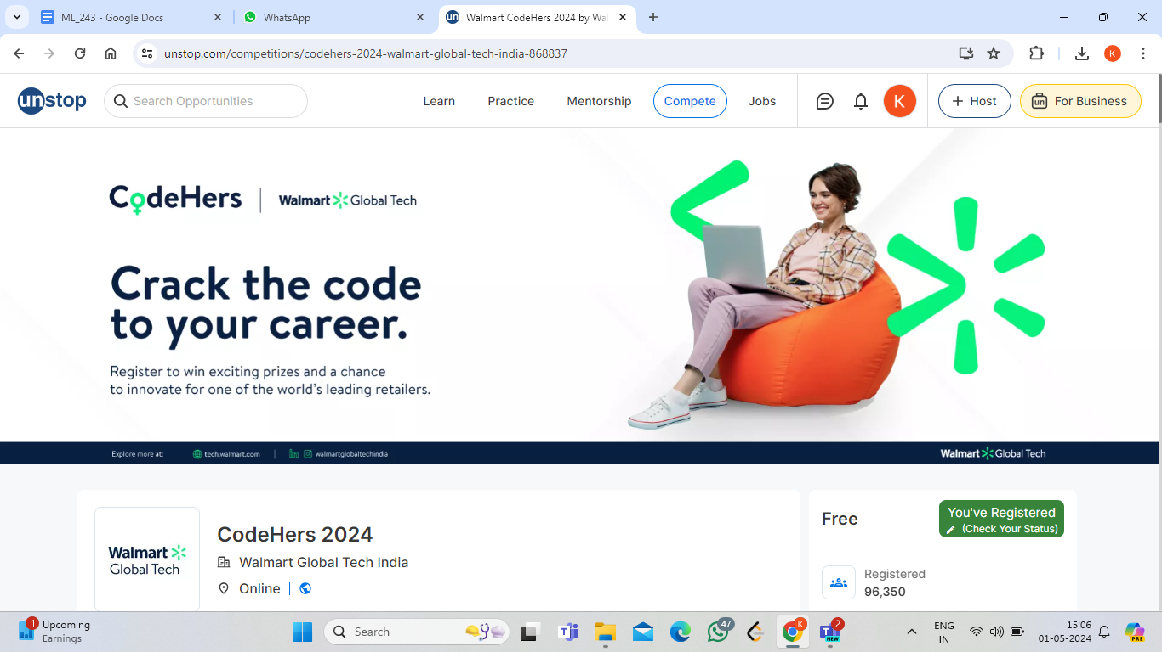

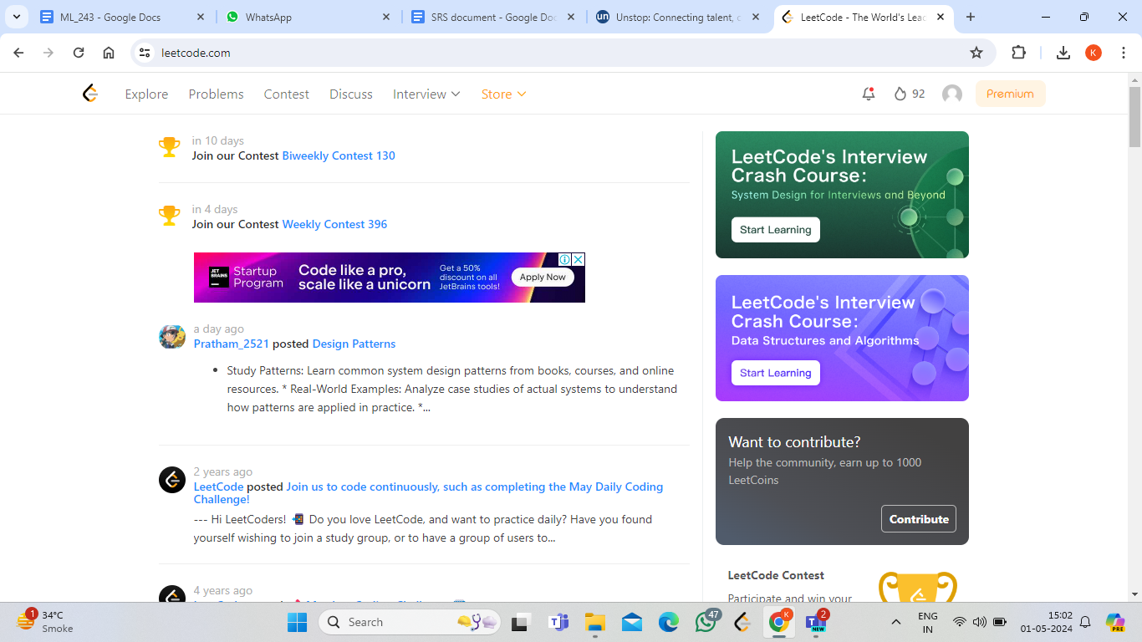

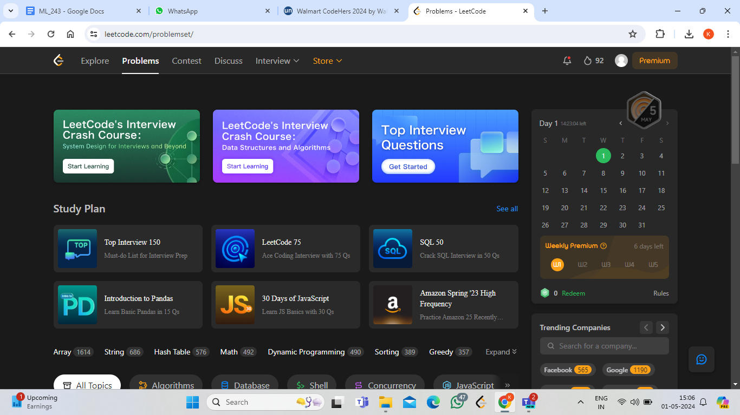

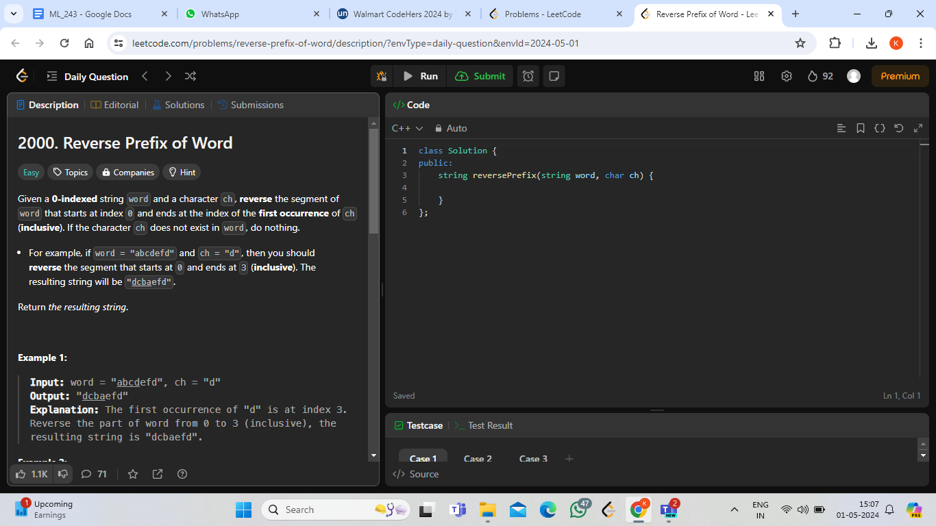

### Hardware Interfaces

* Good Internet Connection
* Laptop or a PC with standard processor and a minimum of 4gb ram
* Camera to be used during hackathons for online proctoring

### Software Interfaces

User Authentication will be done using Google Auth API which would help is authorising access to a user. Then the questions would be stored in a database over the cloud and each time a user clicks on a particular question the same would be loaded from the cloud and will be displayed to the user. Another API which would be used is to check the time complexity of the solutions that is provided by the user i.e check whether it is feasible or not.

### Communications Interfaces

Our platform will be using the HTTP protocol majorly

## Functional Requirements

* User Registration and Authentication: Create accounts, log in, and manage profiles.
* Coding Practice and Challenges: Solve coding problems, track progress.
* Hackathons and Competitions: Participate in coding events.
* Talent Showcase and Portfolio: Showcase skills and connect with employers.
* Notifications and Communication: Stay informed about updates.
* Admin and Moderator Functions: Manage content and resolve issues.

## Behaviour Requirements

### Use Case View

Users - Students, Recruiters, Admin Team

Students can have access to features like practising questions and appear for daily top question or question of the day. They will also have access to a page where the users can buy a specific course and can learn,

The Admin Team will maintain all the questions that are published on the website. They will also look out to identify anomalous test cases and discard them. They will also be approving the courses that the recruiter wants to put on the website or may put courses pertaining to the needs of the recruiter.

The Recruiters will conduct competitions or hackathons over the platform.

*USE CASE DIAGRAM*

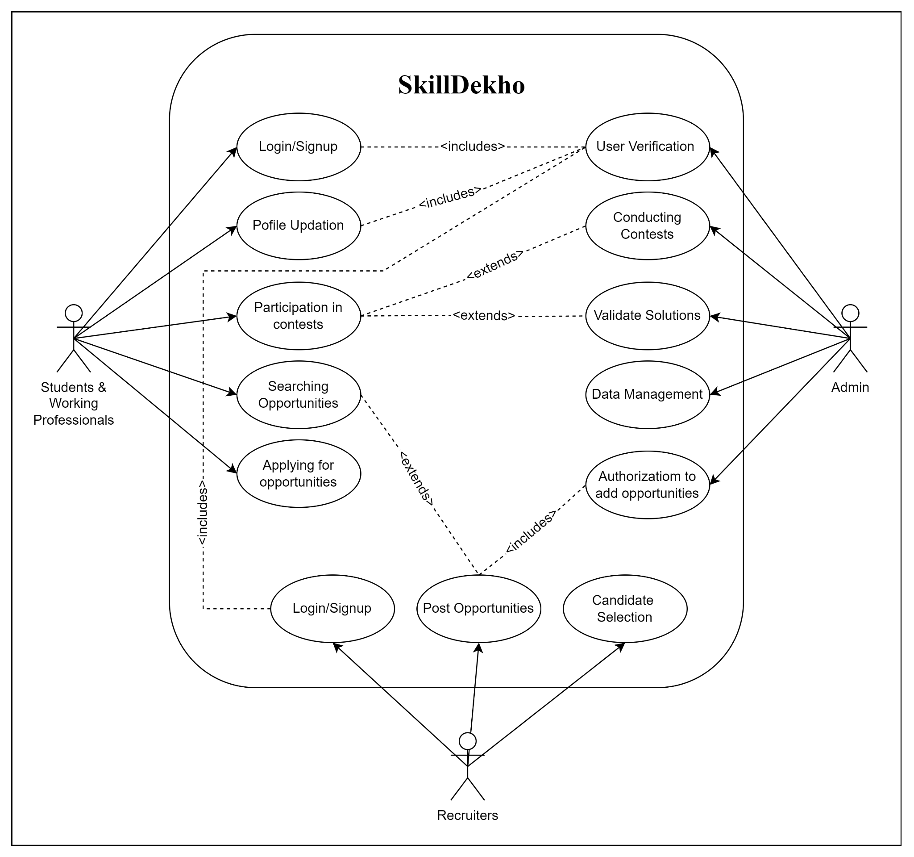

# Other Non-functional Requirements

## Performance Requirements

* Response Time: Any action on the platform, such as submitting code, loading a page, or registering for an event, should have a response time of less than 3 seconds under normal load conditions.
* Scalability: The platform should be able to handle a minimum of 10,000 concurrent users during peak times, such as hackathons or recruitment drives, without significant degradation in performance.
* Availability: The platform should have an uptime of at least 99% to ensure users can access it reliably at all times.
* Data Processing: Coding problem submissions should be processed and evaluated within 1 minute to provide timely feedback to users.
* Database Performance: Database queries should be optimized to ensure efficient retrieval of data, with a maximum query execution time of 100 milliseconds.

## Safety and Security Requirements

* User Data Protection: All user data, including personal information and coding submissions, should be encrypted both in transit and at rest to protect against unauthorized access.
* Authentication and Authorization: User authentication should be implemented using secure methods such as OAuth, and access to different features should be based on user roles to prevent unauthorized actions.
* Code Security: Uploaded code submissions should be scanned for potential security vulnerabilities, such as SQL injection or cross-site scripting (XSS), to prevent exploitation.

## Software Quality Attributes

* Usability: The platform should have an intuitive user interface with clear navigation and instructions, making it easy for users to practice coding and participate in events without requiring extensive training. Error messages should be descriptive and provide guidance on how to resolve issues.
* Maintainability: The codebase should be well-organized and documented, following best practices and design patterns to facilitate future maintenance and updates. Changes to the platform, such as adding new features or fixing bugs, should be easy to implement without affecting the overall functionality.
* Reliability: The platform should be stable and reliable, with minimal downtime or disruptions to user activities. Automated tests should be implemented to ensure that new updates do not introduce regressions or errors.

# Other Requirements

Cloud Database Service: The platform will utilize a cloud-based database service, such as Amazon RDS to manage the database infrastructure.

**Appendix A – Data Dictionary**

| **Level** | **Abbreviation** |
| --- | --- |
| Newbie | N |
| Pupil | P |
| Specialist | S |
| Expert | E |
| Candidate Master | CM |
| Master | M |
| International Master | IM |
| Grandmaster | GM |
| International Grandmaster | IGM |

**Appendix B - Group Log**

| **Date** | **Person In Charge** | **Minutes** |
| --- | --- | --- |
| 21/04/2022 | Sonia D’Silva | This was the first board meeting discussing the key design features of the project and what would be our USP.  The outcome of the meeting was that after rigorous discussion the key design features were finalised. |
| 19/07/2022 | Kreena Shah | User Profiles Enhancement here we decided to enhance user profiles by including coding language preferences and skill levels. This will provide a more personalized experience for our users.  To encourage consistent practice, we’re introducing gamified elements such as badges and achievements. These will motivate users to actively participate and improve their coding skills. |
| 05/12/2022 | Kapil Kashyap | Centralized Event Calendar: Our platform will now feature a centralized event calendar. Users can easily access information about hackathons, competitions, and coding challenges, streamlining their participation.  Collaboration Hub Creation: We’re creating a dedicated space for users to collaborate on coding projects. |